**Voice controlled wheelchair**

**Voice Control Wheelchair**

**Ayushi Gupta ,Ayushi Mangal**

**Department of Instrumentation & Control Engineering, JSSATE, Noida**

**Introduction**

In recent years there has been an increased interest in Human-Computer Interaction Systems allowing for more natural voice communication with machines. Such intelligent systems are especially important for disabled persons. Voice Communication has always been a vast research field in the Human-Computer Interaction, considering that it is the backbone of any application that deals with the human voice. This idea presents voice controlling with Smartphone Arduino and Bluetooth module. We made a intelligent bot, When we give commands forward to motor controller then bot moves in forward direction same concept applied on wheelchair circuit. In this way without human efforts we can move our wheelchair with voice assistant. In future this tracking and monitoring allows user to give input to the computer machine and access the entire system in a hands free manner. Finally we have proposed a step to better development of human life of disabled person.

**Manual wheelchair dimension and weight**

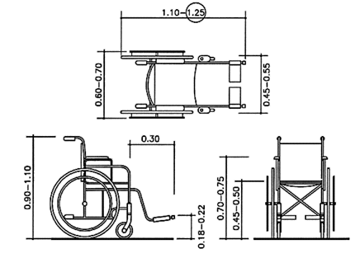

Weight of wheel chair = approx. 10kg

Weight of avg. person = 72 kg

Weight of other equipment (motor, battery, circuits etc.) =8 kg.

Total weight of wheel chair is on 2 wheel is 90kg  
so weight on 1 wheel = 45kg.

**Calculation of parameters**

*Starting torque*

Wheel

F mg/2

F= u*mg/2

Tmax=F*r

r=radius of wheel

F= frictional force

m= total mass on wheel

u=friction coefficient (0.5)

T=torque

We assume our wheelchair max velocity to be approximately 15km/h

So angular velocity

rpmmax= (v*60)/2*pi*r

rpmmax=160

**Component and specification**

1. **Motor-**

Input voltage: 12v

Torque: 60N-m

Rpm: 160

1. **Motor controller**

Specifications: 120W, 9.8Nm, 160 rpm with no load.

1. **Battery**

12 volt rechargeable battery.

1. **Arduino uno**

Microcontroller - ATmega328

Operating Voltage - 5V

Input Voltage (recommended) - 7-12V

1. **Bluetooth module**

It is used to convert the voice signal in to electrical signal. Output of the MIC is given to the voice recognition Module

Model: HC-05

Input Voltage: DC 5V

Communication Method: Serial Communication

Master and slave mode can be switched

**Working**

Here we use a voice recognition module to control performance of the micro controller a microphone. Voice recognition module (Bluetooth module) is trained by giving the 5 commands. These command points 5 address locations of arduino. When command is given the program in the corresponding and thereby controls the movement or rotation of the motor. This is the basic working principle of the ‘voice controlled wheel chair’. Voice is given to the voice recognition module through address location is executed and chair moves accordingly. The battery and battery charger unit is there for power supply.

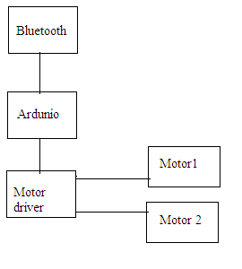

**Flow chart**

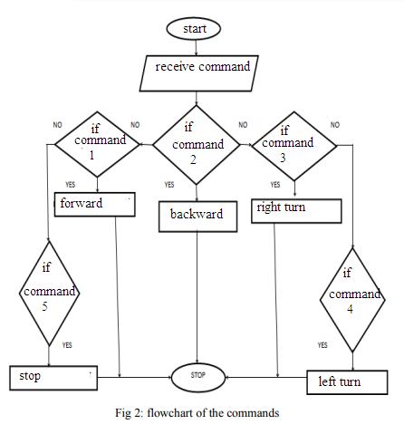

**Result**

When working principle is applied on a bot with the basic reaction command to control bot. Speech recognition used an open-source software arduino **voice control.** We obtained a successful recognition of five reaction commands. Respectively

|  |  |
| --- | --- |
| **Command** | **Action** |
| 1 | Forward |
| 2 | Backward |
| 3 | Turn right |
| 4 | Turn left |
| 5 | Stop |

**Conclusion**-

* The design and implementation of a voice controlled wheelchair for disabled people using arduino and voice recognition module for controlling the motion of a wheelchair is designed. The direction of the wheelchair now can be selected using the specified voice commands.
* The design not only reduce the manufacture cost compared with present market but also will give great competitive with other types of electrical wheelchair. The only thing needed to ride the wheelchair is the synthetic voice commands of the person.
* A system that can directly enhance the lifestyle of a physically disabled person in the community is implemented. This project has many advantages like safety, comfort, energy saving, full automation etc.
* The technology can also enhanced safely for users who use ordinary joystick-controlled wheelchair, by preventing collision with walls, fixed objects, furniture and other people. Thus all the drawbacks of the joy stick controlled wheelchair are overcome by this "voice controlled wheelchair".

**Cost Estimation**

* Manual wheelchair - 3000
* Motor - 600 (each) -700*2=1400
* Motor controller -1000
* Battery-1000
* Arduino uno-350
* Bluetooth module-200

**TOTAL COST = 6950 /- only**

The voice controlled wheelchair is economically at very high price approx 50000, this concept reduce that price up to 8000 with more facilities

**Future Development**

In future we will add GPS module, With the help of GPS we can fix some location like home ,offices etc , we will **add ultrasonic range sensors to avoid obstacles and automatic braking** which make more easy and convenient to use wheel chair.

**References**

1. [IEEE Transactions on Neural Systems and Rehabilitation Engineering](https://ieeexplore.ieee.org/xpl/RecentIssue.jsp?punumber=7333)( Volume: 10 , [Issue: 2](https://ieeexplore.ieee.org/xpl/tocresult.jsp?isnumber=22163) , June 2002 )
2. Masato Nishimori, Takeshi Saitoh and Ryosuke Konishi Tottori University, Tottori, Japan SICE Annual Conference 2007 Sept. 17-20, 2007, Kagawa University, Japan.
3. G Azam and M T Islam* 1Department of Mechanical Engineering, CUET, Chittagong-4349, Bangladesh, International Conference on Physics Sustainable Development & Technology (ICPSDT-2015) (August 19-20, 2015) Department of Physics, CUET.

Break